**Rebecca Birkett | Music player Documentation | Mongodb collections**

## db.getCollection(‘songs’).find({})

[

{

"_id": "632d844f22fc26bbd5277dbc",

"id": "5",

"title": "Lightspeed",

"artist": [

"MDK",

"Sterrezo"

],

"album": "Lightspeed",

"image": "",

"filename": "Lightspeed_MDK_Sterrezo.mp3",

"createdAt": "2022-09-23T10:02:55.487Z",

"updatedAt": "2022-09-23T10:02:55.487Z",

"__v": 0

},

{

"_id": "632c606b48804162786e6d2a",

"id": "4",

"title": "Hyper Beam",

"artist": [

"MDK"

],

"album": "The Singles",

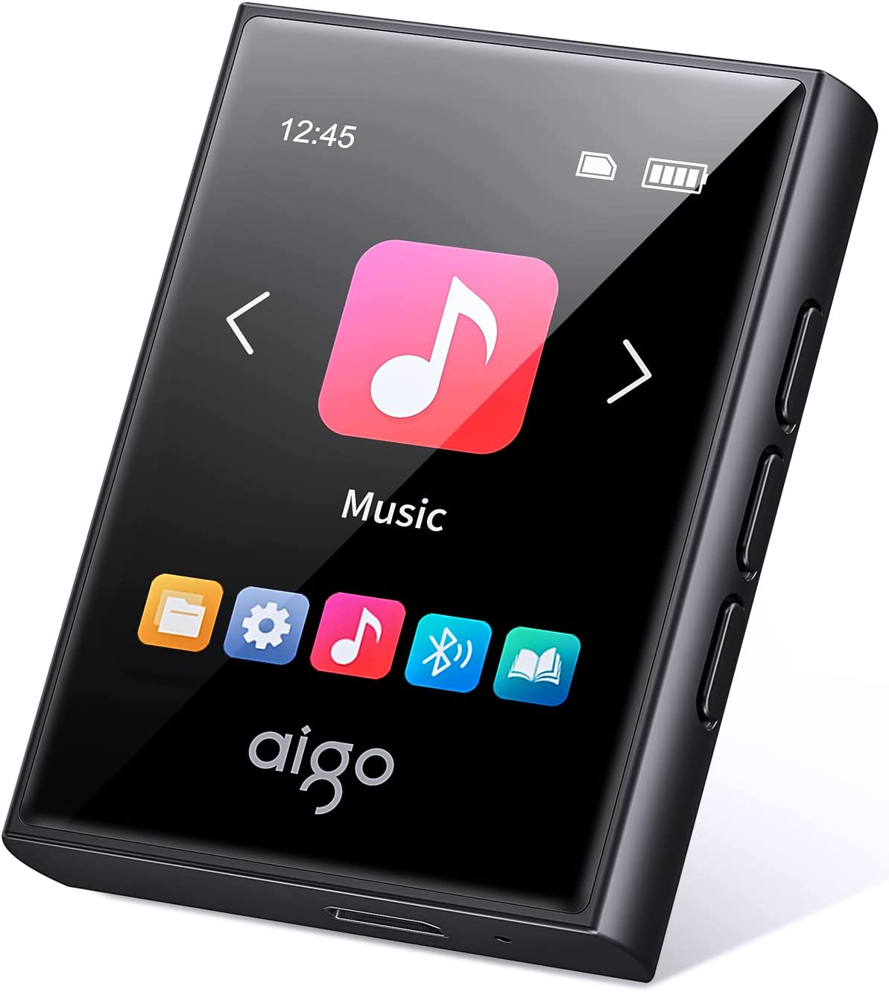

[Example music player](https://www.amazon.co.uk/aigo-Bluetooth-Portable-Lossless-Recorder/dp/B0B67S1DBK/ref=sr_1_5?c=ts&keywords=MP3+&+Digital+Audio+Players&qid=1663152722&s=network-media&sr=1-5&ts_id=573372)

"image": "",

"filename": "HyperBeam_MDK.mp3",

"createdAt": "2022-09-22T13:17:31.693Z",

"updatedAt": "2022-09-23T10:13:29.675Z",

"__v": 0

},

{

"_id": "632c601548804162786e6d27",

"id": "3",

"title": "Phoenix (Orchestral Mix)",

"artist": [

"MDK",

"Nick Sadler"

],

"album": "Rise - The Remixes",

"image": "",

"filename": "Phoenix(OrchestralMix)_MDK_NickSadler.mp3",

"createdAt": "2022-09-22T13:16:05.613Z",

"updatedAt": "2022-09-22T13:16:05.613Z",

"__v": 0

},

{

"_id": "632c5f8d48804162786e6d25",

"id": "2",

"title": "Boss Rush",

"artist": [

"MDK"

],

"album": "Rise",

"image": "",

"filename": "BossRush_MDK_Neowing.mp3",

"createdAt": "2022-09-22T13:13:49.956Z",

"updatedAt": "2022-09-22T13:13:49.956Z",

"__v": 0

},

{

"_id": "632c35a38742054bf371f5ed",

"id": "1",

"title": "Too Hot For Pants",

"artist": [

"MDK"

],

"album": "The Singles",

"image": "",

"filename": "TooHotForPants_MDK.mp3",

"createdAt": "2022-09-22T10:14:59.559Z",

"updatedAt": "2022-09-22T10:14:59.559Z",

"__v": 0

}

]

## db.getCollection(‘playlists’).find({})

[

{

"_id": "6331f6d3139a4601e1fb2b1d",

"title": "Coding Playlist",

"songs": [],

"createdAt": "2022-09-26T19:00:35.079Z",

"updatedAt": "2022-09-26T19:16:03.231Z",

"__v": 0

},

{

"_id": "6331f18b139a4601e1fb2b0e",

"title": "Workout Playlist",

"songs": [],

"createdAt": "2022-09-26T18:38:03.151Z",

"updatedAt": "2022-09-26T19:00:18.992Z",

"__v": 0

},

{

"_id": "6331ec66139a4601e1fb2aed",

"title": "Chillout Playlist",

"songs": [],

"createdAt": "2022-09-26T18:16:06.852Z",

"updatedAt": "2022-09-26T19:00:08.844Z",

"__v": 0

}

]